CLASS 5 REVIEW
Knowing tactics will help you win your chess game. Tactics are a series of moves that lessons your opponents options allowing you to gain something whether its tempo, material or better position.
Forks: When one piece or pawn is attacks two enemy pieces or pawns at the same time. (Also known as a double attack). When the King is one of the attacked pieces, it is called an absolute Fork. The fork of a King and Queen is called a Royal Fork. The Fork of a King, Queen, and Rook is called a Family Fork.
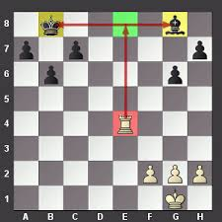
In this example the Rook moving to e8 is forking the King and the Bishop. The King has to move because he will be in check. When he moves, the Rook takes the Bishop.
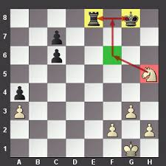
The Knight moves to the f6 square and forks the Rook and King. King has to move because he will be in check and the Knight takes the Rook.
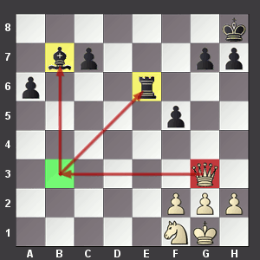
The Queen moves to b3 square and attacks both the Bishop and the Rook. It is important to think ahead in chess. The best move for black after the Queen moves to the b3 square, would be to move the Bishop to c8 to protect the Rook.
Pin: A straight line attack using a Queen, Rook or Bishop. A pin is when a piece is attacked and cannot move without losing a piece of greater value behind it. When the piece of greater value is the King, it is called an absolute pin.
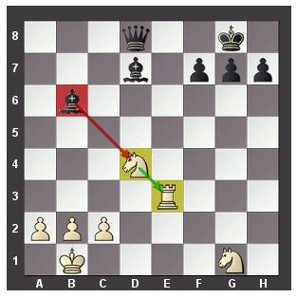
The black bishop on b6 is “pinning” the white Knight to the white Rook. If the knight moves, the Bishop will take the more valuable Rook.
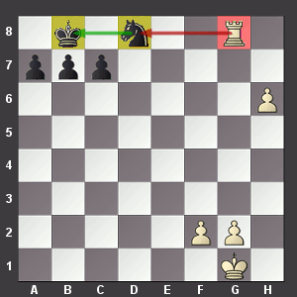
The White Rook on g8 is “pinning” the black knight to the King. This is an absolute pin. The knight cannot move because that will put his King in check.
Skewers / Xrays: A straight line attack using a Queen, Rook or Bishop. A skewer (also called an Xray) is similar to a pin, but the more valuable piece is in front. You are not attacking the piece in front, you are attacking a piece THROUGH another piece. The piece is forced to move allowing a piece of equal or lesser value to be taken. When the King is the front piece, it is called an absolute Skewer. The King MUST move because he is in check allowing you to take the piece behind it.

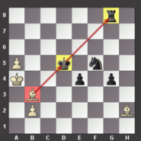
This is an absolute Skewer. The wite bishop is attacking the King and Rook in a straight line. The King has to move because he is in check, allowing the bishop to take the Rook behind it.
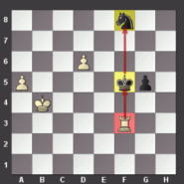
This is also an absolute Skewer. The white Rook is attacking both the King and the Knight. The King has to move allowing the Rook to take the Knight behind it.
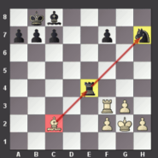
Here the white bishop is attacking both the Rook and the Knight. The white bishop is going to capture one of those two pieces.
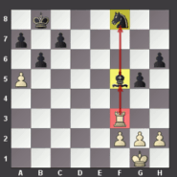
The White Rook is attacking both the Bishop and the Knight. The Rook is going to capture one those two pieces.

