Introduction to Chess Strategy
Beginning chess players discover very quickly that learning how the pieces move is the very tip of the tip of the chess playing iceberg. It's usually sometime during the first several moves of their very first chess game that they find themselves saying, "What now?"
We're going to provide you with some very simple, easy guidelines in chess strategy for playing the chess opening. We're not going to talk about specific openings or give you strings of moves to memorize; these will be some general chess strategy principles which you should think about when starting a chess game.
As your chess career continues you'll also notice that there will be times when it's best to ignore some of these chess strategy and opening principles. Nothing here is carved in granite and there will be times later when you'll violate one or more of these principles. But for right now, these tips are good ones to follow during the first few moves of your games.
An underlying principle in the chess strategy of the chess opening is to try to control the center of the board. The chess board's center is typically defined as the four squares right in the middle of the board (shown here in red):
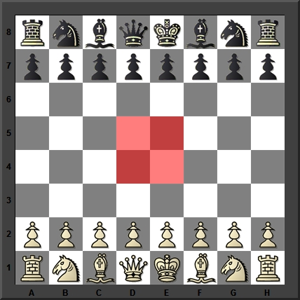
The center is important because your pieces tend to be more mobile the closer they are to the center. Here's an example using the Knight:
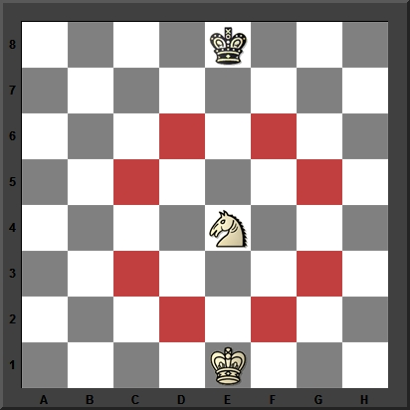
The centrally-placed Knight can move to (and control) eight squares. Now look at this Knight:
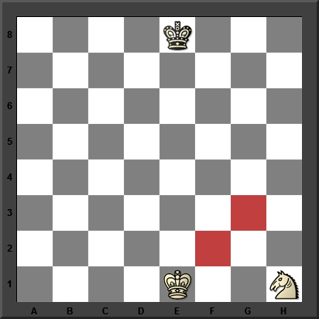
This Knight in the corner controls just two squares.
Center occupation and center control are the two principles of chess strategy which underlay almost all popular chess openings. White would like to occupy the squares d4 and e4 with his pawns, like so:
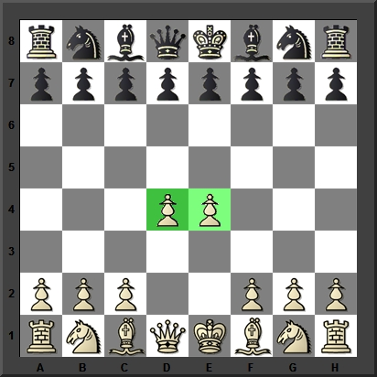
...while Black's chess opening strategy is to occupy both d5 and e5 with his own pawns:
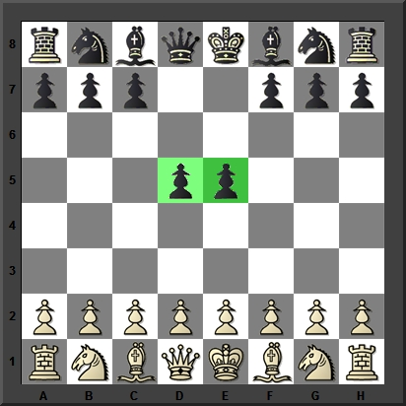
Both players are also trying to prevent their opponent from achieving his strategic goal (so, in most chess openings, neither player actually achieves it), but it's a good opening chess strategy for which both usually strive. The pawns can't stand alone on these squares, either; they need to be supported by other chess pieces or pawns. Remembering this will help you to understand some of the principles we're about to discuss.
1) Good chess strategy suggests you make your first move with the pawn in front of either your King or Queen
Probably the simplest of all chess opening strategies. In both cases, you'll be opening up paths which your other pieces can use to get off of the back rank:
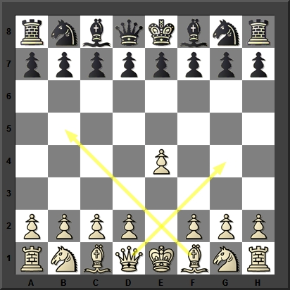
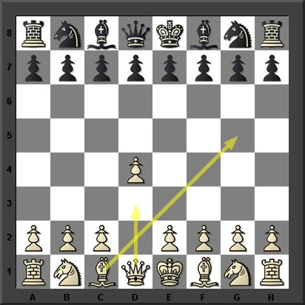
2) Good chess strategy suggests you make good developing moves, and generally develop your Knights before your Bishops
A good developing move is one which gets a chess piece off of its starting square. This is an important chess strategy: you want to get your pieces into the game (where they can actually accomplish something, either aiding your attack or defense) as soon as you can. And the reason why you'll usually want to develop your Knights before your Bishops is because it's easier to find a good square on the chess board for your Knights:
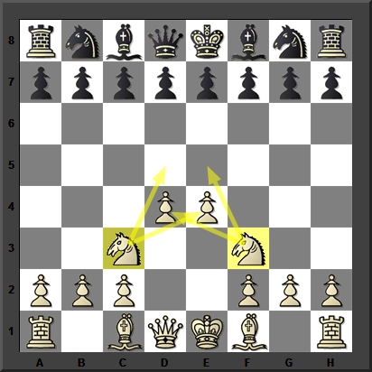
This is an example of a "can't go wrong" Knight development; the Knights defend the pawns and control those strategically important central squares. Knowing the right spot for a Bishop often isn't so easy.
3) Good chess strategy suggests you try not to move the same piece twice in the opening
Don't move the same piece around aimlessly; the best chess opening strategy is to find a good developing square for it. After you've developed a piece, don't move it again unless you absolutely have to; concentrate on developing another piece.
4) Good chess strategy suggests that your King's safety is crucial; castle early if you can
A big exception to the principle of centralizing your pieces concerns your King. In the opening and middlegame, the center is the worst place for your King. Castling is a great way to safeguard your King from sudden chess tactics and even checkmate - it gets the King away from the center and develops one of your Rooks at the same time. Top level chess strategy!
5) Good chess strategy suggests you don't advance more than one or two pawns in the chess opening, and definitely not a pawns in front of your castled King
You need to advance a couple of pawns so that your pieces can develop, but be aware that advancing lots of pawns will weaken your defenses. So the best chess opening strategy is to move one or two pawns in the opening (see principle #1), but not more. (There are exceptions to this; you'll learn them later.)
6) Good chess strategy suggests you make when you develop your pieces, try to make moves which threaten something
Here's a simple example. Both players have advanced their e-pawns - now it's White's move:
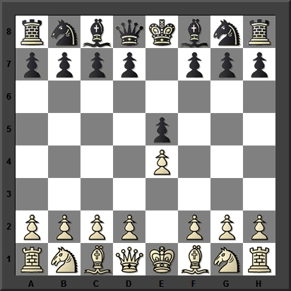
White decides to develop his Knight, and his move threatens Black's center pawn on the e5 square - accomplishing two goals of proper chess strategy at the same time:
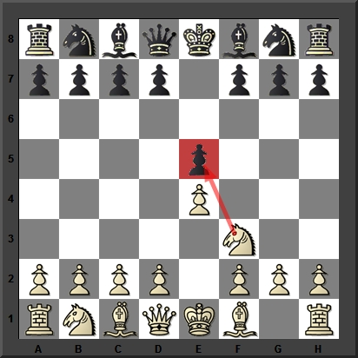
That's a very simple example of making a good developing move which also threatens something. Now Black has to make a move which will somehow defend the threatened pawn, and also develop his own chess position.
7) Good chess strategy suggests you don't bring your Queen out early
The Queen is your most powerful piece but she can't win a chess game all by herself. She's also a very enticing target for your opponent early in a game where she can be easily trapped on a crowded chessboard. Generally, chess opening strategy dictates that the Queen is one of the last pieces you'll develop.
As you progress in your chess career, you will learn that there are always exceptions to general strategic principles. But for right now, as you're taking your first steps on the road to chess improvement, these chess strategy tips will help you avoid many catastrophes at the chess board.
Copyright 2010, Steven A. Lopez and ChessCentral. All rights reserved.

