CLASS 3 REVIEW
- Each Chess Game is typically made up of three stages. The Opening, the Middle Game and the End Game.
In the OPENING you want to do the following:
- Control the Center squares (e4, e5, d4, d5)
- Develop your minor Pieces (move your Knights and your Bishops toward the center to get into the game and prepare for castling)
- Castle the King into safety.
- Connect your Rooks.

The MIDDLE GAME is the second stage of the game. This usually starts once your minor and major pieces are developed and you have castled your king and connected your rooks. This is where most of the action takes place through plans of attack using tactics and defending your own pieces.

The END GAME is the last stage of the game. It is usually after most pieces are traded off. If there are still pawns on the board, they will be in a race to promote before Checkmate occurs. Also, the King becomes more active in the End Game.

When you attack the King with one of your pieces or pawns, it is called putting the King in CHECK. It is a forcing move and the King must get out of Check. If the King is trapped and can’t get out of the CHECK, this is CHECKMATE and the game is OVER.

To get out of CHECK, you can do one of three things:

A: Move your King AWAY to a safe square. (run away like chicken)
B: BLOCK the check with another piece.
C: CAPTURE: Capture the attacking piece.

Remember that your pieces and pawns must work together to Checkmate the enemy King. You want to control the number of squares that the King can move to. Don’t waste moves checking the King without a purpose. Useless checks often allow your opponent to gain a tempo. Some reasons to Check the King are:

- To prevent your enemy from being able to Castle.
- To Force a move so that you can defend an attack on one of your own pieces.
- To Force a move so that you can advance a Pawn.
- As part of a combination in a tactic.
- To avoid a Checkmate.

Terms:

Passed Pawn-When you have a pawn that can safely make it to your enemy side and can be promoted.

Tempo- The amount of moves. A loss of a tempo would be taking two moves where one would do. This may, or may not, be critical in the early stages of a game. When you move the same piece twice allowing your opponent and extra move to develop his pieces.

Opposition- Your King can never occupy a square next to the enemy King. Think of there being a magnetic force field preventing the Kings from touching. This will be an important concept to understand later when you use Opposition in the End Game to help promote a passed pawn.

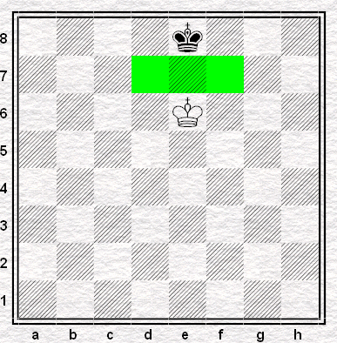

Check- When a King is under attack by a Piece or pawn. A check is a forcing move. The King must get out of Check.

Checkmate- When a King is trapped and has no safe place to go.
Stalemate- When there are no safe moves on the board, but the King is NOT in CHECK. This results in a draw.

En Passant: This is a special Pawn rule. It does not get played very often. This only applies when you get a pawn to the 5th rank for White or the 4nd rank for Black. If your opponent then chooses to initially move his pawn 2 spaces from his starting position (placing his next to your pawn), you may capture that pawn as though he only moved 1 space from his starting position. You only have this one opportunity to capture this way.
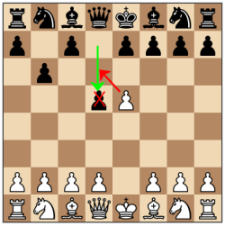
In this example, white has gotten his d pawn to the 5th rank. Black has moved his e pawn two spaces from his starting position. White can capture En Passant as though the e pawn would have moved one space.

