CLASS 4 REVIEW
Checkmate is a position when one King is in check and is trapped and cannot get out of check. Checkmating your enemy King is the GOAL OF THE GAME.
Some examples of Checkmates are:
In Your Face Checkmate – When you have a Queen and King against a lone King, you can always achieve checkmate if you know how to use your King and Queen together to push the enemy King against a wall by “shrinking the box” and then placing the Queen in the King’s face with Checkmate. The Queen is being protected by her King.
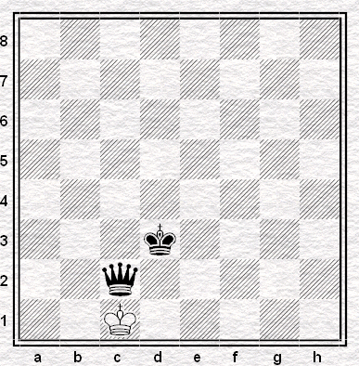

Rook Roller – When you have two Rooks against a lone King, you can always achieve a checkmate if you know how to use your Rooks to Roll the King to the edge of the board.
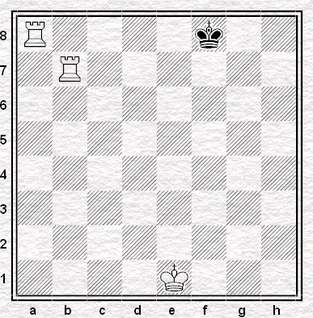

Back Rank Checkmate – When your enemy King is on the back rank and is blocked in by his own pieces.
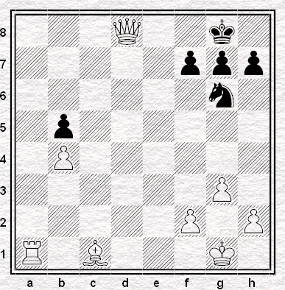
Recognizing Checkmating Patterns – notice how two pieces work together to achieve checkmate.
